Q. Shell script to print table of given number by FOR loop.

Code:

echo "Qureshi --- 210451"

echo "Enter any number:"

read num

for i in 1 2 3 4 5 6 7 8 9 10

do

echo "$num \* $i = expr $num \\* $i"

done

Output:

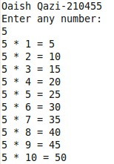

Q. Shell script to print the following output using FOR loop.

Code:

echo "Qureshi --- 210451"

rows=4

for((i=rows; i>=1; --i))

do

for((space=0; space < rows-i; ++space))

do

echo -n " "

done

for((j=i; j <= 2\*i-2; ++j))

do

echo -n "\* "

done

for((j=0; j < i-1; ++j))

do

echo -n "\* "

done

if((i==1))

then

echo "\* "

fi

echo

done

Output:

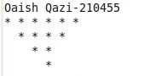

Q. Shell script to display Fibonacci series for n numbers.

Code:

echo "Qureshi --- 210451"

echo "Enter value for n: "

read N

a=0

b=1

echo "The Fibonacci series is: "

for (( i=0; i<N; i++ ))

do

echo "$a "

fn=$((a + b))

a=$b

b=$fn

done

Output:

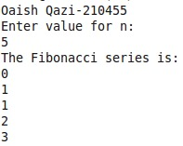

Q. Shell script to display tables of 2 to 10 numbers.

Code:

echo "Qureshi --- 210451"

echo "Enter any number: "

read n

for i in 1 2 3 4 5 6 7 8 9 10

do

echo "$n \* $i = `expr $i \\* $n`"

done

Output:

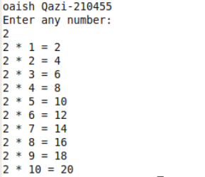

Q. Shell script to accept five-digit number and perform addition of all digits.

Code:

echo "Qureshi --- 210451"

Num=12345

g=$Num

s=0

while [ $Num -gt 0 ]

do

k=$(( $Num % 10 ))

Num=$(( $Num / 10 ))

s=$(( $s + $k ))

done

echo “sum of digits of $g is : $s"

Output:

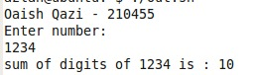

EXERCISE:

Q. Shell script to print day of week list using For loop.

Code:

i=1

for day in Mon Tue Wed Thu Fri Sat Sun

do

echo "Weekday $((i++)) : $day"

done

Output:

Weekday 1 : Mon

Weekday 2 : Tue

Weekday 3 : Wed

Weekday 4 : Thu

Weekday 5 : Fri

Weekday 6 : Sat

Weekday 7 : Sun

Q. Shell script to print day of week list using For loop.

Code:

r=1

while [ $r -le 4 ]

do

count=1

c=1

while [ $c -le $r ]

do

echo -n "$count "

count=$(( $count + 2 ))

c=$(( $c + 1 ))

done

echo

r=$(( $r + 1 ))

done

Output:

1

1 3

1 3 5

1 3 5 7

Q. The case statement for performing various mathematical operations.

Code:

echo "Enter two numbers: "

read a

read b

echo "Enter Choice: "

echo "1. Addition"

echo "2. Subtraction"

echo "3. Multiplication"

echo "4. Division"

read ch

case $ch in

1)res=`echo $a + $b | bc`

;;

2)res=`echo $a - $b | bc`

;;

3)res=`echo $a \\* $b | bc`

;;

4)res=`echo "scale=2; $a / $b" | bc`

;;

esac

echo "Result: $res"

Output:

Enter two numbers:

20

10

Enter Choice:

1

Result: 30

Enter two numbers:

20

10

Enter Choice:

2

Result: 10